***Appendix No. 5***

*to the Rector's Ordinance No. R.0211.4.2025 from 27 January 2025*

Table of contents

Appendix No. 5 to the Rector's Ordinance No. 1

1. Logging in to the Electronic Document Workflow (EOD) system 1
2. Main Application Window 1
3. Starting a document workflow 2
4. Application functionalities 2
   1. Step 1 – Start 2
   2. Step 2 – Choosing a company 3
   3. Step 3 – Supervisor's opinion 4
   4. Step 4 – Agreement data 5
   5. Step 5 – Implementation of the internship 5
   6. Step 6 – Report 6
   7. Step 7 – Signing the report 6
   8. Step 8 – Employer (Internship Organizer) Assessment 7
   9. Step 9 – Verification by a supervisor, entry into USOS 7

# Logging in to the Electronic Document Workflow (EOD) system

**Instructions for logging in to the university's EOD system** are available at:

<https://csi.uek.krakow.pl/UKS%20-%20Uczelniane%20Konto%20Studenckie/>

## Main Application Window

After logging in, the Webcon BPS Portal home page opens (link to the website [https://eod.uek.krakow.pl](https://eod.uek.krakow.pl/) ).

In the "Select Application" menu (located at the top left), select "Student Internships". After selection, the main application window will appear.

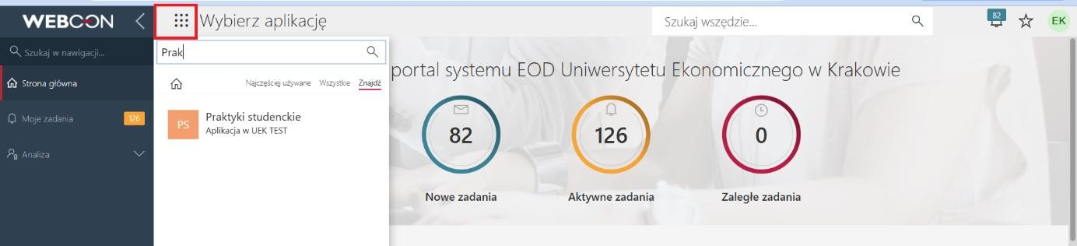

Fig. 1.

# Starting a document workflow

In order to start the document workflow (Internship Application), click the tile that starts the workflow (Fig. 2). After starting the workflow, fill in the available form.

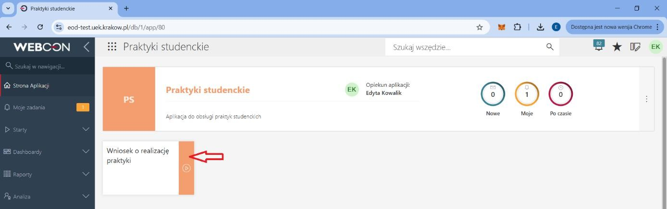

Fig. 2.

# Application functionalities

### Step 1 – Start

The form consists of two parts: a) data of the applicant – student (Fig. 3a); b) data on the internship (Fig. 3b). In part a) the Applicant field is suggested automatically, the degree field should be selected from the list, after indicating the degree, the remaining data will be filled in automatically. In part b) select the Type of internship, internship and Coordinator - the remaining data will be filled in automatically. The completed form is sent by the student for the next step.

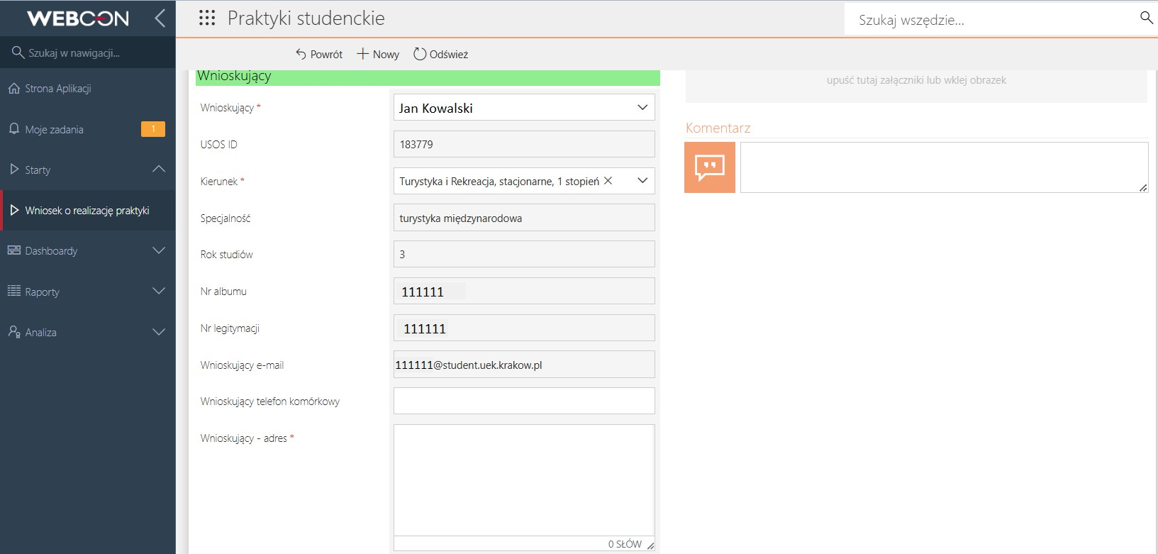

Fig. 3a.

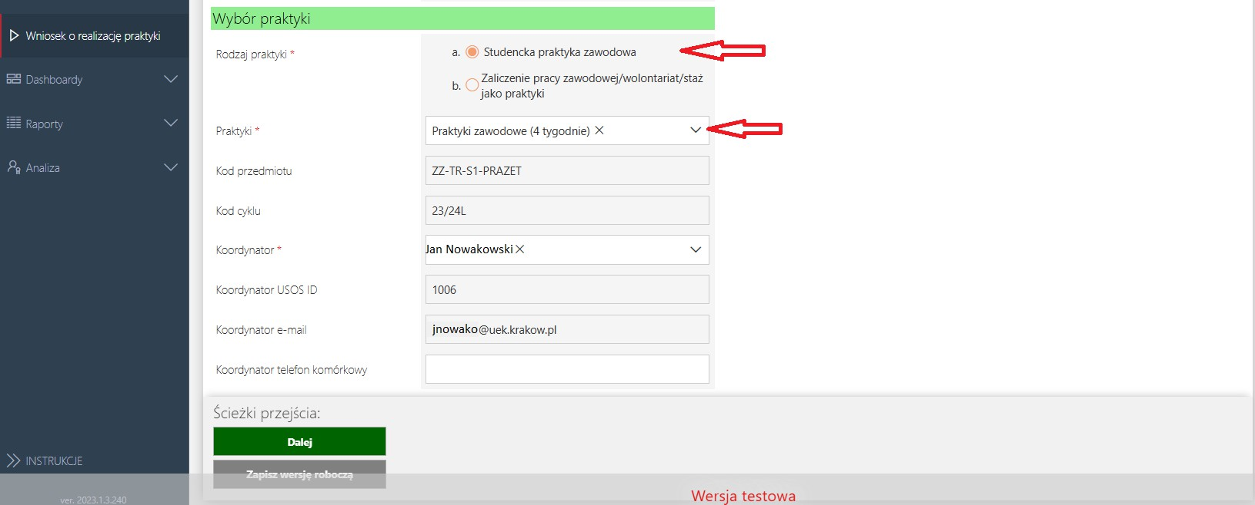

Fig. 3b.

### Step 2 – Choosing a company

In step 2, regardless of the type of internship, you should indicate the company (Internship Organizer - employer) with whom the internship will be carried out. The company should be selected from the list, if the company is not on the list, it should be added by clicking the link marked in Figure 4a. In the case of adding a Polish company, it should be searched for by entering its KRS, NIP or REGON number(s) in the search engine, in the case of a foreign company it should be manually entered with company data (Fig. 4b). The data about the company downloaded from the list are filled in automatically on the form, the remaining data marked with an asterisk must be filled in manually. At this step, it is required to attach appropriate annexes depending on the type of internship. In the case of a student internship, you need to add proof of insurance, in the case of crediting professional work/volunteering/placement as an internship, you need to add proof of insurance and a contract. The completed application should be sent for the next step.

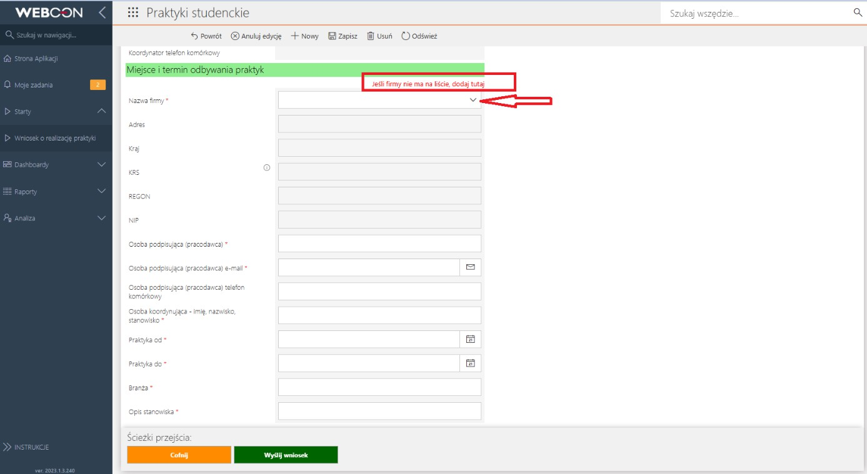

Fig. 4a.

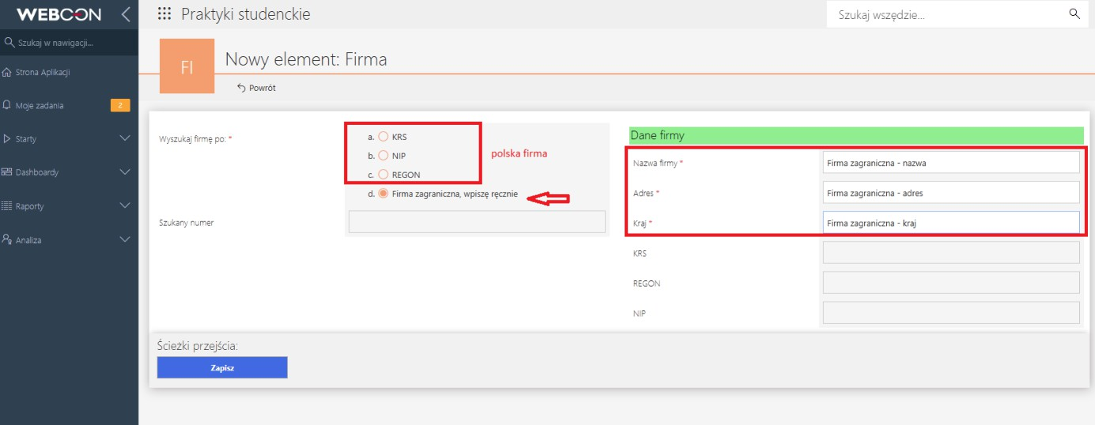

Fig. 4b.

### Step 3 – Supervisor's opinion

In step 3, regardless of the type of practice, the application is sent to the Internship Supervisor, who verifies whether the indicated employer (Internship Organizer) represents the appropriate industry. The Supervisor can accept the request or revert for correction. An accepted application for student internship, goes to step 4 – Data for the contract; in the case of crediting professional work/volunteering/apprenticeship as an internship, the application goes to step 6 – Report.

### Step 4 – Contract data

In step 4, the application returns to the applicant (student). At this stage, it is necessary to indicate the form of signing the contract, generate the contract and the referral (Fig. 5).

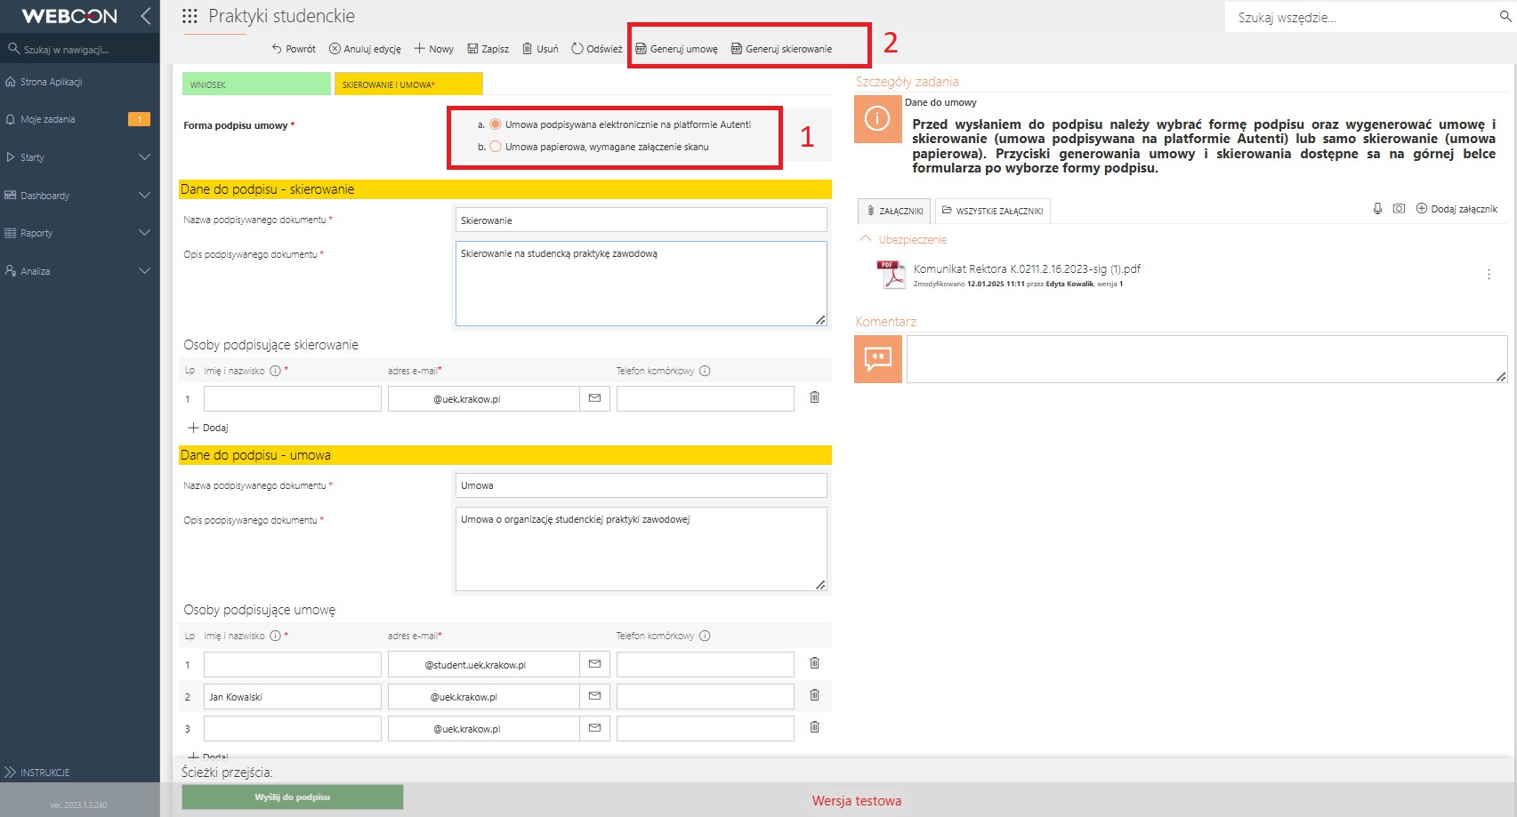

Fig. 5.

### Step 5 – Implementation of the internship

After signing the documents, the application moves on to the next step of Internship implementation and in this step it waits for the internship to be completed. In order to close (credit) the internship, click the Completed internship button and go to the Report step (Fig. 6).

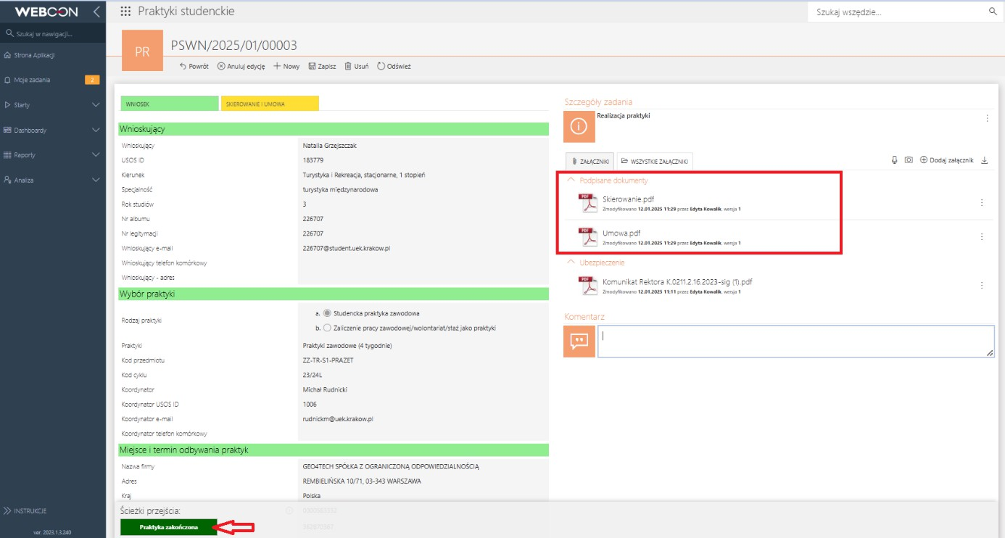

Fig. 6.

### Step 6 – Report

This is the stage at which, regardless of the type of internship, data on the activities performed during the internship must be completed, on the basis of which a report is generated in the next step (Fig. 7).

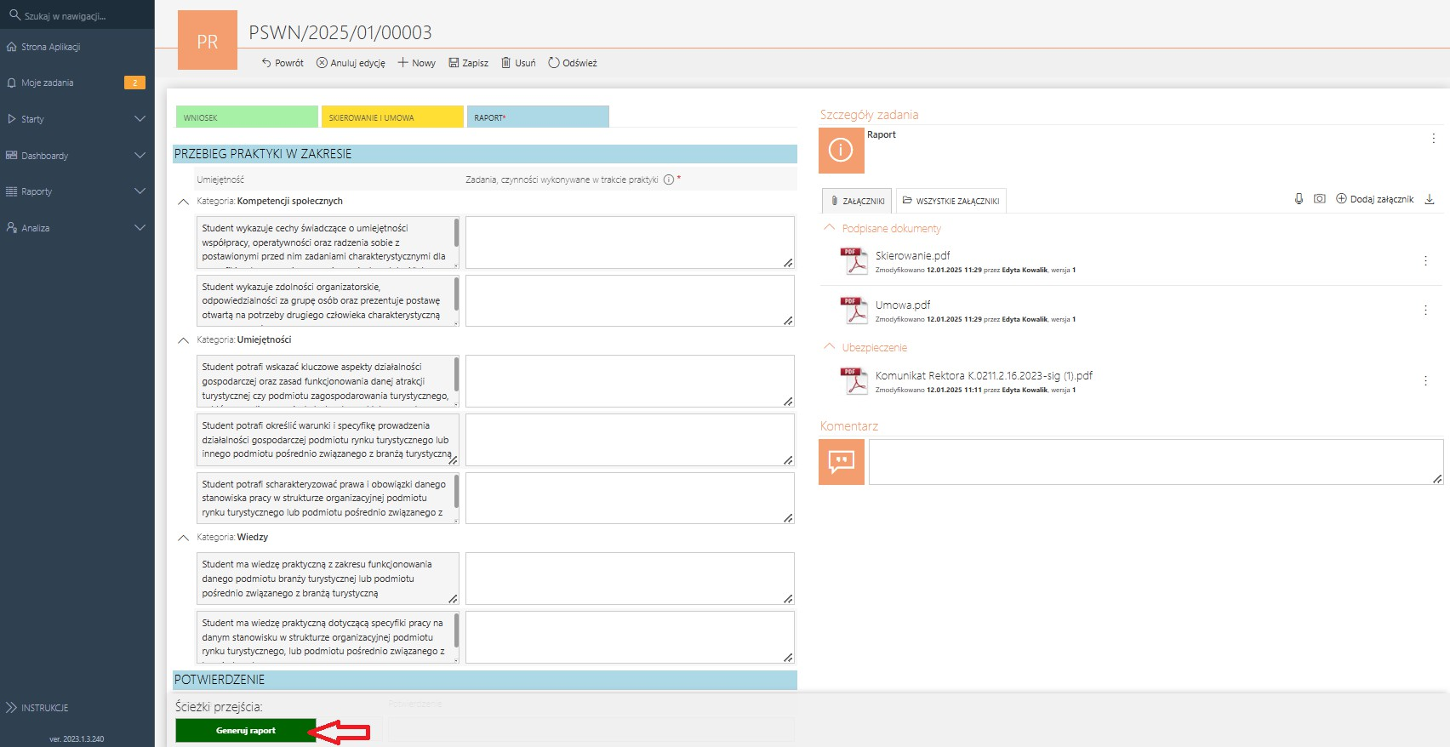

Fig. 7.

### Step 7 – Signing the report

The step on which, regardless of the type of practice, the report should be printed, delivered to the employer (the Internship Organizer) for signing, a scan of the signed document should be posted, and then proceed to the assessment of the employer (Fig. 8).

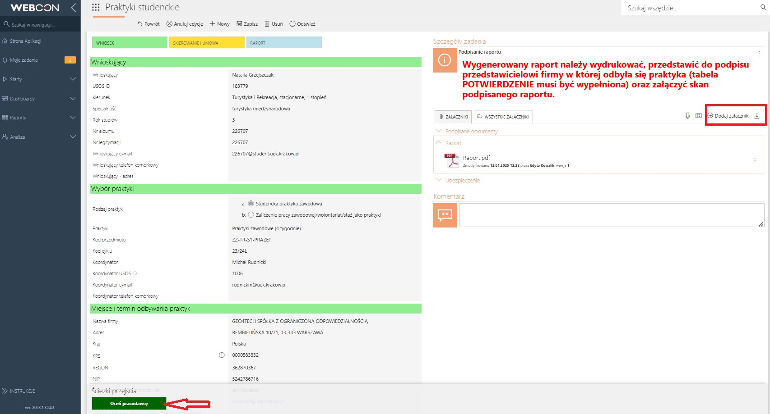

Fig. 8.

### Step 8 – Employer (Internship Organizer) Assessment

A step on which, regardless of the type of internship, a questionnaire should be completed to assess the learning outcomes achieved by the student during the internship and to identify the factors conducive to its implementation at a given Internship Organizer. After completing the questionnaire, all documentation should be sent to the Internship Supervisor for verification and crediting of the internship (Fig. 9).

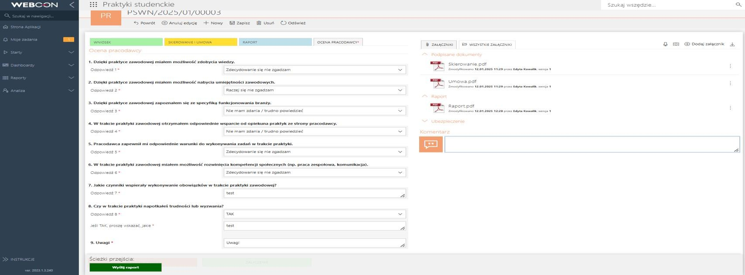

Fig. 9.

### Step 9 – Verification by the supervisor, entry in USOS

A step on which, regardless of the type of internship, the Internship Supervisor confirms the achievement of learning effects on the basis of a scan of the report signed by the employer (Internship Organizer) and confirms the successful completion of the internship. The internship supervisor has the possibility to withdraw documents to be corrected (Fig. 10). In the case of successful conclusion of the internship, the internship supervisor automatically enters the internship into the USOS system (Fig. 11).

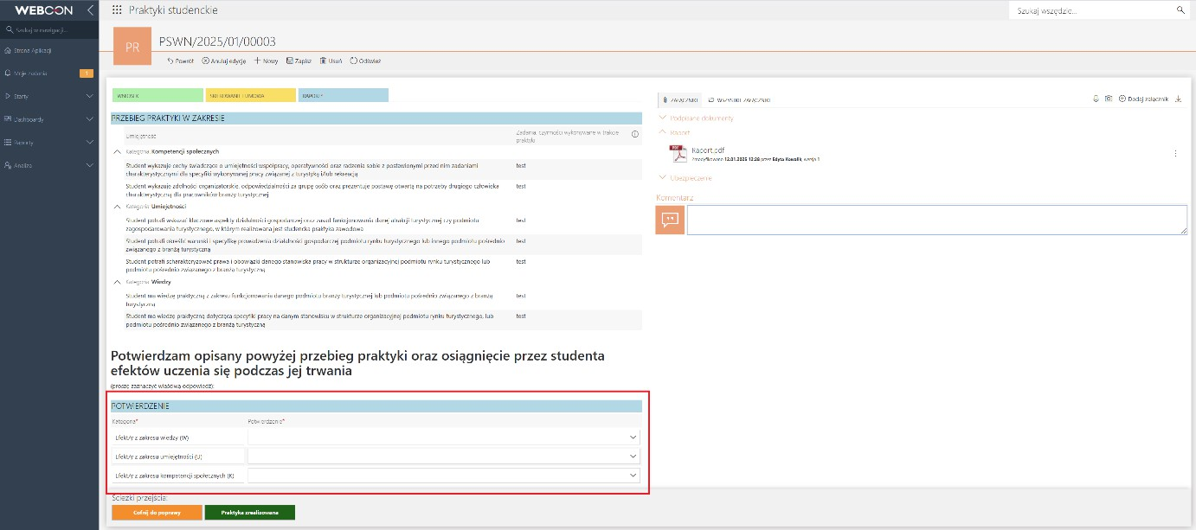

Fig. 10.

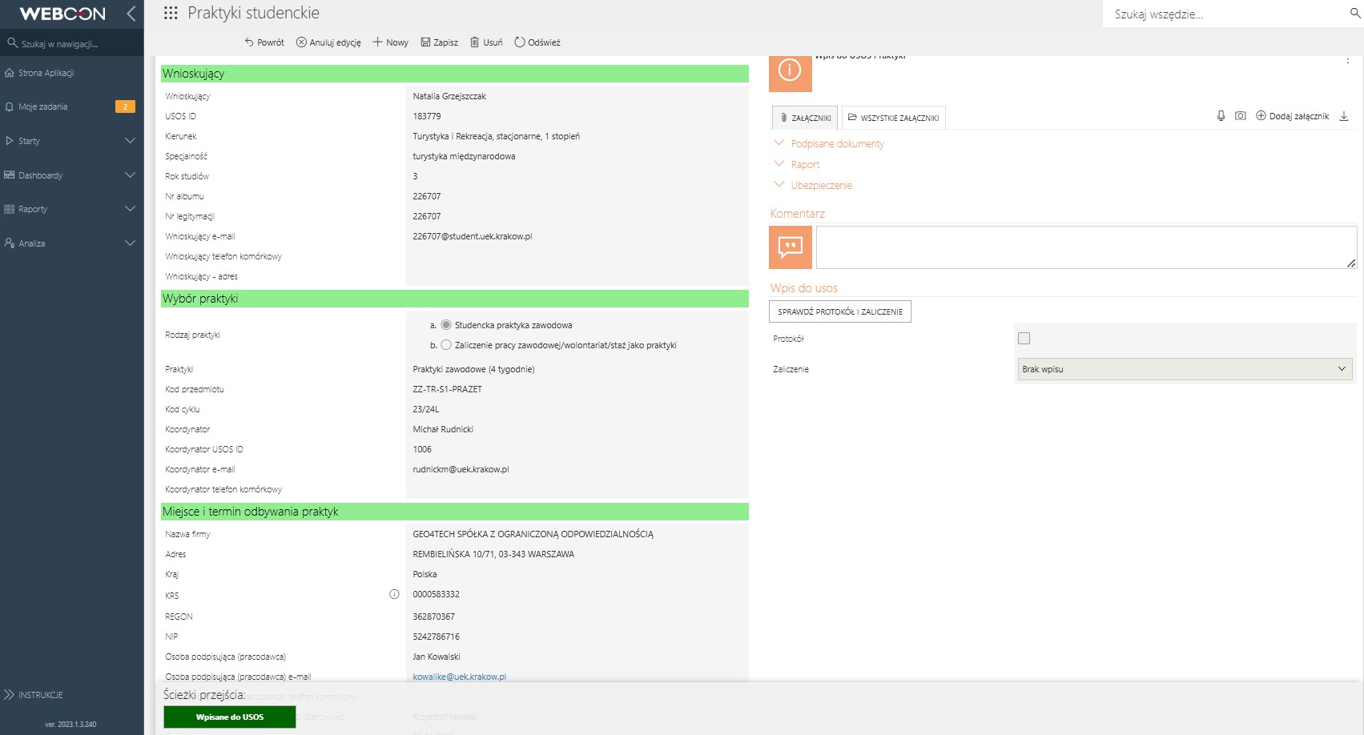

Fig. 11.